Newsletter Date
Volume 1, Issue 1

Ghana

Geography of the area, population, ethnic/religious groups, literacy rate, physical features, any diseases that affect population, poverty rate, environmental issues regarding water. (Pick 4 factors to write about)

Second Story: Government/Economy
What kind of government do they have? (military dictatorship, parliamentary democracy, etc?) Is it a stable government? What is their relationship to the United States? Are they allies? If possible, what do they trade with the United States? Where does their economy fall on the economic continuum – are they more market or command? What is their GDP? What are their main imports and exports?

Summary of Articles:

• Geography

• Government and Economy.

• Tourism Interests.

Each section must have at least one paragraph (5-6 sentences)
EX: The Warrior King, modernly known as Ghana, was founded in the 11th century, and home to one of the most powerful ethnic groups in Africa, the Ashanti. Ghana is located along the Gulf of Guinea and the Atlantic Ocean, in the sub region of West Africa. This area is considered tropical with season that are both wet and dry.
Ghana is considered a multicultural country, with 27 million people. 98% of the population is Black African, and the majority of citizens are from the Ashanti ethnic group. The religious population consists of 5% traditional faiths, 72% Christian, and 23% Muslim.
Ghana has one of the highest high school enrollment rates in the entire continent of Africa. 95% of Ghana’s children receive an education, funded mostly by the government. The literacy rate is 81%, with males having a slightly higher average than females. The government often funds up to 80% of higher level education as well as lower grades.

Ghana hosts a unitary presidential democracy, where the president serves as both head of government and head of state. Ghana is known as a strong ally of the United States, and has had visits by several U.S. Presidents. The government favors international political and economic cooperation. They are very active in the United Nations and the African Union.
Ghana is an economic regional power in West Africa. After becoming independent of Great Britain in 1957, it has risen in economic prosperity. In its mixed economy, the focus is on industrial minerals, hydrocarbons, and precious metals. It is the second largest producer of cocoa in the world, and the largest producer of gold.
Main Sources Used (must have AT LEAST 3 sources):
https://en.wikipedia.org/wiki/Ghana

By: Mr. Kenny

Tourism (or why there is limited/no tourism). Add up to 3 photographs of tourist sites. What are three things you can see or do in your country?
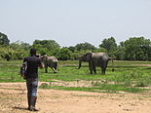

Ghana is one of the top tourist destinations in Africa. In 2011, over 1 million people came to enjoy the sights.
When visiting Ghana and its warm tropical yearlong climate, a visitor can expect to see diverse wildlife, waterfalls, beaches, caves, mountains, lakes, and history.
Ghana is the 11th most friendly country, the 43rd, most peaceful country, and ranks 108th out of the most popular 139 countries to visit.
If you plan to go to Ghana, you will need to apply for a visa from the Consulate of Ghana at least 2 weeks in advanced. You must also have a certificate of having a Yellow Fever vaccine.

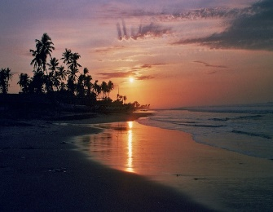

Scoring Guide for Country Project
Content | Points Possible | Total Points | Comments
Geography
4 factors of geography explained thoroughly | 4
Government/Economy
Government Explained (What kind and is it stable?) | 2
Econ Explained (More market or command based, exports and imports) | 2
Tourism
Explained with positive and/or negative aspects | 2
3 Pictures of relevant tourist destinations | 3
Conventions
Summary of Articles (well-written and thorough, reader can clearly understand what is being discussed) | 3
Sources (3) | 3
Minimal Grammatical Mistakes | 1
 |  | Total Points _____/20
 |  | Grade:

