Sub Work 11/13
Reflect on Veteran’s Day.
- Watch the Brainpop on Veteran’s Day:
--cmshusky
--lighthouse
2. Complete the following on your own paper: http://www.elcivics.com/military-uniforms.pdf
3. Look at this picture: It is titled: The Veteran in the New Field: Winslow Homer 1865: Answer the following:
1. What is going on around 1865, that would case this title to be created?
2. What are some of the objects in the picture, that could also be symbols?
3. How do veterans adjust to life back after a war?
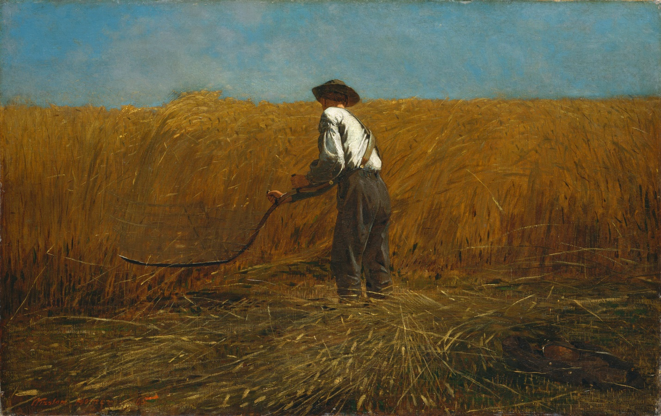
4. Work on Country Projects!

